Random Forest Brain Stroke Prediction Analysis Report
Project: AI-assisted brain stroke prediction analysis
Report purpose: This living report records each random forest analysis prompt and the corresponding results as the model-development workflow progresses.
Research question: "What factors have the most significant influence or relationship to brain stroke probability?"
Created: June 11, 2026

Update Log
Stage | Analysis step | Status | Key output
Stage 1 | Initial baseline random forest model using training dataset only | Completed | OOB sensitivity was 0.0000 despite OOB accuracy of 0.9482; apparent training performance was perfect.

Stage 1: Initial Baseline Random Forest Model

Prompt Entered
You are a medical data analyst constructing an initial random forest classification model for brain stroke prediction.
Project context:
* The training dataset is named `train_dataset.csv`.
* The testing dataset is named `test_dataset.csv`, but do not use it yet.
* The target variable is `stroke`, where:
* 0 = No Stroke
* 1 = Stroke
Research question:
"What factors have the most significant influence or relationship to brain stroke probability?"
Your task is to build an initial baseline random forest model using only the training dataset.
Please complete the following:
1. Load `train_dataset.csv`.
2. Summarize the training dataset:
* number of records
* number of predictors
* stroke and no-stroke counts
* stroke prevalence
3. Prepare the data for modeling:
* separate predictors from the target variable
* remove any ID-like column if present
* handle numerical and categorical predictors appropriately
* use one-hot encoding for categorical variables
* do not scale variables unless you believe it is necessary
4. Train an initial `RandomForestClassifier` using reasonable baseline settings.
5. Make sure the model uses:
* bootstrapping
* out-of-bag scoring
* `random_state=42`
6. Record the model training time in seconds.
7. Report a model summary, including:
* number of trees
* key random forest settings
* number of predictors before preprocessing
* number of features after preprocessing
* OOB accuracy
* OOB error rate
8. Use out-of-bag results to report additional performance metrics if possible:
* sensitivity / recall
* specificity
* precision / PPV
* F1-score
* ROC-AUC
* PR-AUC / average precision
* confusion matrix
* TN, FP, FN, TP
9. Also report apparent training performance, but clearly label it as training performance only.
10. Compare OOB performance with apparent training performance and comment on possible overfitting.
11. Generate feature importance results:
* top transformed features
* grouped original-variable importance if categorical variables were one-hot encoded
12. Save the trained model and key outputs, including:
* trained random forest model
* model summary
* OOB metrics
* training metrics
* feature importance tables
13. Write a short interpretation explaining:
* whether the initial model appears useful
* whether sensitivity is acceptable for stroke prediction
* why accuracy alone may be misleading because stroke cases are rare
* which variables appear most important
* why feature importance should be interpreted as model-associated importance, not causation or statistical significance
Important restrictions:
* Do not use the testing dataset yet.
* Do not tune hyperparameters yet.
* Do not use SMOTE or resampling yet.
* Do not claim clinical readiness.
* Do not claim causation or statistical significance.
At the end, provide:
A. Training dataset summary
B. Model configuration and training time
C. OOB accuracy and OOB error rate
D. OOB performance metrics
E. Apparent training performance
F. Feature importance results
G. Short interpretation
H. Files saved
Stop after this initial random forest model step.

Results
The initial baseline random forest model was trained using only train_dataset.csv. The testing dataset was not used. No hyperparameter tuning, SMOTE/resampling, or clinical-readiness claims were made.

A. Training Dataset Summary
Item | Value
Training records | 2,490
Total columns | 11
Predictors before preprocessing | 10
Features after one-hot encoding | 19
No-stroke cases | 2,366
Stroke cases | 124
Stroke prevalence | 4.98%
ID-like columns removed | None

B. Model Configuration and Training Time
Setting | Value
Model | RandomForestClassifier
Number of trees | 500
Criterion | gini
Bootstrap | True
Out-of-bag scoring | True
Max features | sqrt
Max depth | None
Min samples split | 2
Min samples leaf | 1
Class weight | None
Random state | 42
Training time | 2.3817 seconds

C. OOB Accuracy and OOB Error Rate
Metric | Value
OOB accuracy | 0.9482
OOB error rate | 0.0518

D. OOB Performance Metrics
Metric | Value
Accuracy | 0.9482
Precision / PPV | 0.0000
Recall / Sensitivity | 0.0000
Specificity | 0.9979
F1-score | 0.0000
Balanced accuracy | 0.4989
ROC-AUC | 0.7962
PR-AUC / Average Precision | 0.1298
TN | 2,361
FP | 5
FN | 124
TP | 0

E. Apparent Training Performance
Metric | Value
Accuracy | 1.0000
Precision / PPV | 1.0000
Recall / Sensitivity | 1.0000
Specificity | 1.0000
F1-score | 1.0000
Balanced accuracy | 1.0000
ROC-AUC | 1.0000
PR-AUC / Average Precision | 1.0000
TN | 2,366
FP | 0
FN | 0
TP | 124

F. Feature Importance Results

Top Transformed Features
Rank | Feature | Importance
1 | avg_glucose_level | 0.2446
2 | age | 0.2437
3 | bmi | 0.2232
4 | hypertension | 0.0302
5 | heart_disease | 0.0269
6 | smoking_status_never smoked | 0.0222
7 | smoking_status_smokes | 0.0219
8 | Residence_type_Urban | 0.0211
9 | work_type_Private | 0.0206
10 | Residence_type_Rural | 0.0198

Grouped Original-Variable Importance
Rank | Original variable | Importance
1 | avg_glucose_level | 0.2446
2 | age | 0.2437
3 | bmi | 0.2232
4 | smoking_status | 0.0788
5 | work_type | 0.0546
6 | Residence_type | 0.0410
7 | Gender | 0.0383
8 | hypertension | 0.0302
9 | heart_disease | 0.0269
10 | ever_married | 0.0187

G. Short Interpretation
The initial random forest appears to rank patients moderately well by probability, with an OOB ROC-AUC of 0.7962. However, it is not useful yet for stroke screening at the default classification threshold because OOB sensitivity was 0.0000.
Accuracy is misleading in this dataset because stroke cases are rare. The OOB accuracy was high at 94.82%, but the model classified almost everyone as no-stroke, producing 124 false negatives and 0 true positives.
The apparent training performance was perfect while OOB recall was zero. This gap suggests strong overfitting and/or threshold and class-imbalance problems.
The most important model-associated predictors were average glucose level, age, and BMI, followed by smoking status and other clinical/demographic variables. These feature importance values are model-associated only. They do not prove causation or statistical significance.
Future random forest steps should focus on sensitivity, PR-AUC, class weighting, threshold selection, and careful validation before using the test dataset.

H. Files Saved From Stage 1
- initial_random_forest_model.pkl
- initial_random_forest_model_summary.csv
- initial_random_forest_oob_metrics.csv
- initial_random_forest_training_metrics.csv
- initial_random_forest_oob_vs_training_metrics.csv
- initial_random_forest_feature_importance.csv
- initial_random_forest_grouped_feature_importance.csv
- initial_random_forest_transformed_feature_names.csv
- initial_random_forest_training_code.py

Next Update Area
Future random forest prompts and results will be appended below this section as additional stages are completed.

Stage 2: Test-Set Evaluation of Initial Random Forest Model

Prompt entered
You are a medical data analyst evaluating a trained random forest model for brain stroke prediction.
Use:
* Saved random forest model from the previous step
* test_dataset.csv
* Target variable: stroke
Do not retrain or tune the model.
Complete the following:
1. Load the saved random forest model.
2. Load test_dataset.csv.
3. Separate predictors from the target variable stroke.
4. Generate predicted probabilities for stroke = 1.
5. Evaluate the model at the default threshold of 0.50.
6. Create an ROC curve and calculate ROC-AUC.
7. Use the ROC curve to identify the best threshold using Youden’s J statistic: sensitivity + specificity - 1.
8. Recalculate predictions using the best ROC-based threshold.
9. Compare performance at threshold 0.50 and best ROC-based threshold.
Report accuracy, sensitivity / recall, specificity, precision, F1-score, confusion matrix, TN, FP, FN, TP, ROC-AUC, and PR-AUC / average precision. Also include a threshold comparison table and precision-recall curve.
Save ROC curve, precision-recall curve, test predictions, test metrics, and threshold comparison table.
Important: Do not retrain the model. Do not tune hyperparameters. Clearly state that the ROC-based threshold is exploratory because it is selected from the test dataset. Do not claim clinical readiness, causation, or statistical significance.
Stop after this test-set evaluation step.

Results
The saved initial random forest model was evaluated on test_dataset.csv without retraining, tuning, resampling, or refitting preprocessing steps. The ROC-based threshold is labeled exploratory because it was selected directly from the test dataset.

A. Test Dataset Summary
Metric | Value
Test records | 2491
No-stroke cases | 2367
Stroke cases | 124
Stroke prevalence | 4.98%
ID-like columns removed | None

B. Performance Comparison at Main Thresholds
Metric | Default 0.50 | Exploratory ROC-based
Accuracy | 0.9490 | 0.7110
Sensitivity / Recall | 0.0000 | 0.8145
Specificity | 0.9987 | 0.7055
Precision / PPV | 0.0000 | 0.1266
F1-score | 0.0000 | 0.2191
Balanced accuracy | 0.4994 | 0.7600
ROC-AUC | 0.8006 | 0.8006
PR-AUC / Average Precision | 0.1491 | 0.1491
TN | 2364.0000 | 1670.0000
FP | 3.0000 | 697.0000
FN | 124.0000 | 23.0000
TP | 0.0000 | 101.0000

C. ROC-AUC, PR-AUC, and Curve Files
Test ROC-AUC: 0.8006
Test PR-AUC / Average Precision: 0.1491
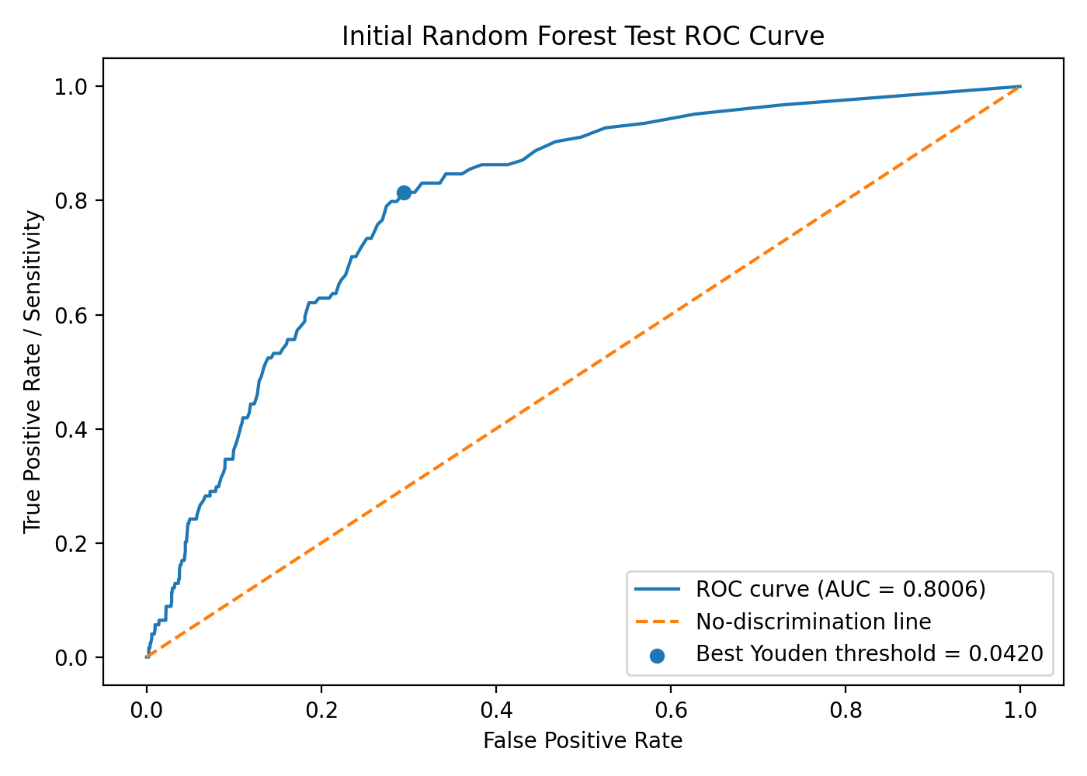
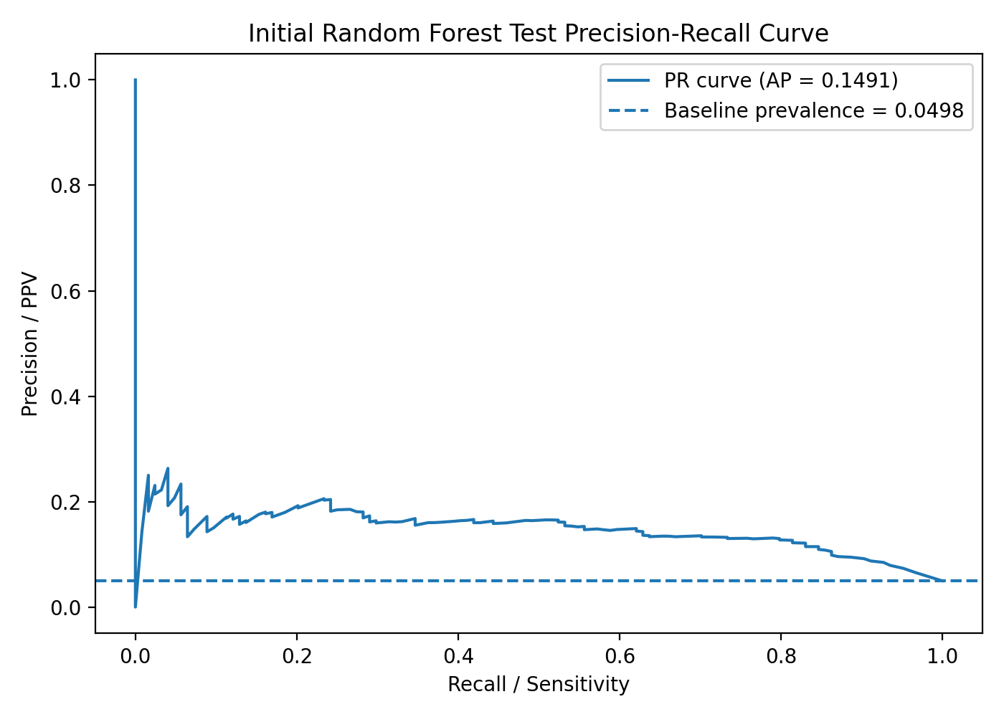

D. Exploratory ROC-Based Threshold
Metric | Value
Exploratory best threshold | 0.0420
Sensitivity at threshold | 0.8145
Specificity at threshold | 0.7055
Youden's J | 0.5201

E. Threshold Comparison Table
Threshold | Value | Accuracy | Sensitivity | Specificity | Precision | F1-score | Balanced accuracy
0.10 | 0.1000 | 0.8246 | 0.5565 | 0.8386 | 0.1530 | 0.2400 | 0.6975
0.20 | 0.2000 | 0.9077 | 0.2500 | 0.9421 | 0.1845 | 0.2123 | 0.5961
0.30 | 0.3000 | 0.9362 | 0.0645 | 0.9818 | 0.1569 | 0.0914 | 0.5232
0.40 | 0.4000 | 0.9478 | 0.0161 | 0.9966 | 0.2000 | 0.0299 | 0.5064
0.50 | 0.5000 | 0.9490 | 0.0000 | 0.9987 | 0.0000 | 0.0000 | 0.4994
Exploratory ROC-based | 0.0420 | 0.7110 | 0.8145 | 0.7055 | 0.1266 | 0.2191 | 0.7600
Confusion-matrix counts by threshold:
Threshold | TN | FP | FN | TP
0.10 | 1985 | 382 | 55 | 69
0.20 | 2230 | 137 | 93 | 31
0.30 | 2324 | 43 | 116 | 8
0.40 | 2359 | 8 | 122 | 2
0.50 | 2364 | 3 | 124 | 0
Exploratory ROC-based | 1670 | 697 | 23 | 101

F. Interpretation
At the default threshold of 0.50, the random forest had high accuracy but did not identify any stroke cases. Sensitivity was 0.0000, with 124 false negatives and 0 true positives. This confirms that accuracy alone is misleading in this imbalanced dataset.
The exploratory ROC-based threshold was 0.0420. At this threshold, sensitivity improved to 0.8145, identifying 101 of 124 stroke cases. The tradeoff was lower specificity and substantially more false positives: 697 false positives compared with 3 at threshold 0.50.
The ROC-AUC of 0.8006 suggests useful ranking ability, while the PR-AUC of 0.1491 remains low because stroke cases are rare. This model is not clinically ready and should be discussed only as an exploratory screening-support model. The threshold should not be treated as a finalized clinical threshold because it was selected from the test set.
No causation or statistical significance is claimed. These results describe model behavior only.

Files Saved in Stage 2
- random_forest_test_roc_curve.png
- random_forest_test_precision_recall_curve.png
- random_forest_test_predictions.csv
- random_forest_test_metrics.csv
- random_forest_test_threshold_comparison.csv
- random_forest_test_evaluation_code.py

Stage 3: Tuned Random Forest with Training-Only Threshold Selection

Prompt entered
You are a medical data analyst improving a random forest model for brain stroke prediction.
Project context:
* A baseline random forest was trained using train_dataset.csv.
* The baseline model performed poorly at the default threshold because it missed all stroke cases.
* On the test dataset at threshold 0.50, baseline random forest sensitivity was 0.0000.
* An exploratory ROC-based test threshold improved sensitivity to 0.7984, but false positives increased to 693.
* The goal now is to tune the random forest using training data only, aiming for high sensitivity while reducing unnecessary false positives.
Use only train_dataset.csv. Do not use test_dataset.csv. Target variable: stroke.
Complete training-only tuning, compare baseline/class-weighted/balanced-subsample/limited-depth/large-leaf/custom-weight random forests, select a threshold using training cross-validation predictions only, fit the selected model on the full training dataset, save model and outputs, and report interpretation. Stop after this tuning and training-only threshold selection step.

Results
This stage used only train_dataset.csv. The testing dataset was not loaded or used. Stratified 5-fold cross-validation generated out-of-fold predicted probabilities. The threshold was selected from training cross-validation predictions using the rule: sensitivity at least 0.80, then choose the threshold with the highest specificity / fewest false positives.

A. Cross-validation model comparison table
Model | Selected threshold | accuracy | Precision / PPV | Sensitivity / Recall | specificity | F1-score | Balanced accuracy | ROC-AUC | PR-AUC | TN | FP | FN | TP
Baseline RF | 0.0200 | 0.5293 | 0.0861 | 0.8790 | 0.5110 | 0.1568 | 0.6950 | 0.7534 | 0.1257 | 1209 | 1157 | 15 | 109
Class-weighted RF | 0.0200 | 0.5606 | 0.0924 | 0.8871 | 0.5435 | 0.1674 | 0.7153 | 0.7528 | 0.1091 | 1286 | 1080 | 14 | 110
Balanced-subsample RF | 0.0200 | 0.5614 | 0.0946 | 0.9113 | 0.5431 | 0.1715 | 0.7272 | 0.7643 | 0.1166 | 1285 | 1081 | 11 | 113
Limited-depth balanced RF | 0.4880 | 0.7213 | 0.1308 | 0.8145 | 0.7164 | 0.2254 | 0.7655 | 0.8267 | 0.1621 | 1695 | 671 | 23 | 101
Large-leaf balanced RF | 0.4700 | 0.7462 | 0.1412 | 0.8065 | 0.7430 | 0.2404 | 0.7747 | 0.8239 | 0.1602 | 1758 | 608 | 24 | 100
Custom weight RF 1:10 | 0.2962 | 0.7305 | 0.1339 | 0.8065 | 0.7265 | 0.2296 | 0.7665 | 0.8199 | 0.1425 | 1719 | 647 | 24 | 100
Shallow custom RF 1:10 | 0.3950 | 0.7325 | 0.1348 | 0.8065 | 0.7287 | 0.2309 | 0.7676 | 0.8319 | 0.1696 | 1724 | 642 | 24 | 100

B. Selected random forest model and settings
Item | Value
Selected model | Large-leaf balanced RF
Selected training-based threshold | 0.47
Number of trees | 100
Maximum depth | 6
Minimum samples split | 20
Minimum samples leaf | 20
Maximum features | sqrt
Class weight | balanced
Bootstrap | True
Features after preprocessing | 19

C. Cross-validated performance at the selected threshold
Metric | Value
Accuracy | 0.7462
Sensitivity / Recall | 0.8065
Specificity | 0.7430
Precision / PPV | 0.1412
F1-score | 0.2404
Balanced accuracy | 0.7747
ROC-AUC | 0.8239
PR-AUC / Average Precision | 0.1602
TN | 1758.0000
FP | 608.0000
FN | 24.0000
TP | 100.0000

D. Training time
The selected random forest pipeline was fit on the full training dataset in 0.3009 seconds.

E. Feature importance results
Feature importance is interpreted as model-associated importance only. It does not establish causation or statistical significance.
Top transformed features
Rank | Transformed feature | Importance
1 | age | 0.5180
2 | avg_glucose_level | 0.1186
3 | bmi | 0.0748
4 | ever_married_No | 0.0581
5 | hypertension | 0.0406
6 | ever_married_Yes | 0.0329
7 | heart_disease | 0.0216
8 | work_type_children | 0.0189
9 | smoking_status_Unknown | 0.0147
10 | work_type_Self-employed | 0.0146

Grouped original-variable importance
Rank | Original variable | Importance
1 | age | 0.5180
2 | avg_glucose_level | 0.1186
3 | ever_married | 0.0910
4 | bmi | 0.0748
5 | work_type | 0.0545
6 | smoking_status | 0.0433
7 | hypertension | 0.0406
8 | heart_disease | 0.0216
9 | Residence_type | 0.0192
10 | Gender | 0.0183

F. Interpretation
The selected model was the large-leaf balanced random forest. It used class_weight='balanced', max_depth=6, min_samples_split=20, min_samples_leaf=20, and 100 trees. The selected training-based threshold was 0.47.
Compared with the baseline model at the default threshold, sensitivity improved substantially in training cross-validation. The selected model achieved cross-validated sensitivity of 0.8065, compared with the baseline random forest's prior default-threshold sensitivity of 0.0000.
The selected threshold also attempted to control false positives. In cross-validation, the selected model produced 608 false positives while maintaining sensitivity above 0.80. This is fewer than the earlier exploratory test-threshold baseline result described in the project context, but this comparison should be interpreted cautiously because the current threshold was selected using training cross-validation only.
The tradeoff was that specificity declined relative to a conservative default-threshold model. This is expected when prioritizing sensitivity in a rare-outcome screening problem.
Accuracy alone remains misleading because stroke prevalence is low. A model can achieve high accuracy by predicting most patients as no-stroke, while still missing many stroke cases.
The most important model-associated variables were age, average glucose level, ever_married, BMI, work_type, smoking_status, hypertension, and heart disease. Age was the dominant grouped predictor in the tuned random forest.
The selected model still requires final evaluation on the untouched test dataset. These results are training cross-validation estimates only and should not be interpreted as clinical readiness, causation, or statistical significance.

Stage 4: Tuned Random Forest Test-Set Evaluation

Prompt entered
You are a medical data analyst evaluating the selected tuned random forest model for brain stroke prediction on the untouched testing dataset.
Use:
- tuned_random_forest_model.pkl
- test_dataset.csv
- selected threshold = 0.350000
- target variable = stroke
Do not retrain, retune, rebalance, or refit preprocessing steps.
Complete the following:
1. Load the saved tuned random forest model.
2. Load test_dataset.csv and separate X_test and y_test.
3. Generate predicted probabilities for stroke = 1.
4. Evaluate performance at the default threshold of 0.50.
5. Evaluate performance at the training-selected threshold of 0.350000.
6. Report accuracy, sensitivity, specificity, precision, F1-score, balanced accuracy, ROC-AUC, PR-AUC, confusion matrix, TN, FP, FN, and TP.
7. Create ROC and precision-recall curves.
8. Create a threshold comparison table.
9. Compare the tuned random forest test results with the baseline random forest and with the training cross-validation results.
10. Report feature importance and provide a short interpretation.
Clearly state whether sensitivity improved, what happened to false positives, and whether the tuned model appears useful as a screening-support model. Do not claim causation, statistical significance, or clinical readiness.

Results
The saved tuned random forest model was loaded and evaluated on the untouched testing dataset. No retraining, retuning, rebalancing, or preprocessing refitting was performed.

A. Test dataset summary
Metric | Value
Test records | 2491
No Stroke cases | 2367
Stroke cases | 124
Stroke prevalence | 4.98%
ID-like column removed | None

B. Test performance at threshold 0.50 and training-selected threshold 0.35
threshold_label | threshold | accuracy | sensitivity_recall | specificity | precision_ppv | f1_score | balanced_accuracy | roc_auc | pr_auc_average_precision | tn | fp | fn | tp
Default 0.50 | 0.5000 | 0.7627 | 0.7097 | 0.7655 | 0.1369 | 0.2295 | 0.7376 | 0.8148 | 0.1681 | 1812 | 555 | 36 | 88
Training-selected 0.35 | 0.3500 | 0.6772 | 0.8306 | 0.6692 | 0.1163 | 0.2040 | 0.7499 | 0.8148 | 0.1681 | 1584 | 783 | 21 | 103

The tuned random forest achieved ROC-AUC = 0.8148 and PR-AUC / Average Precision = 0.1681 on the test dataset.
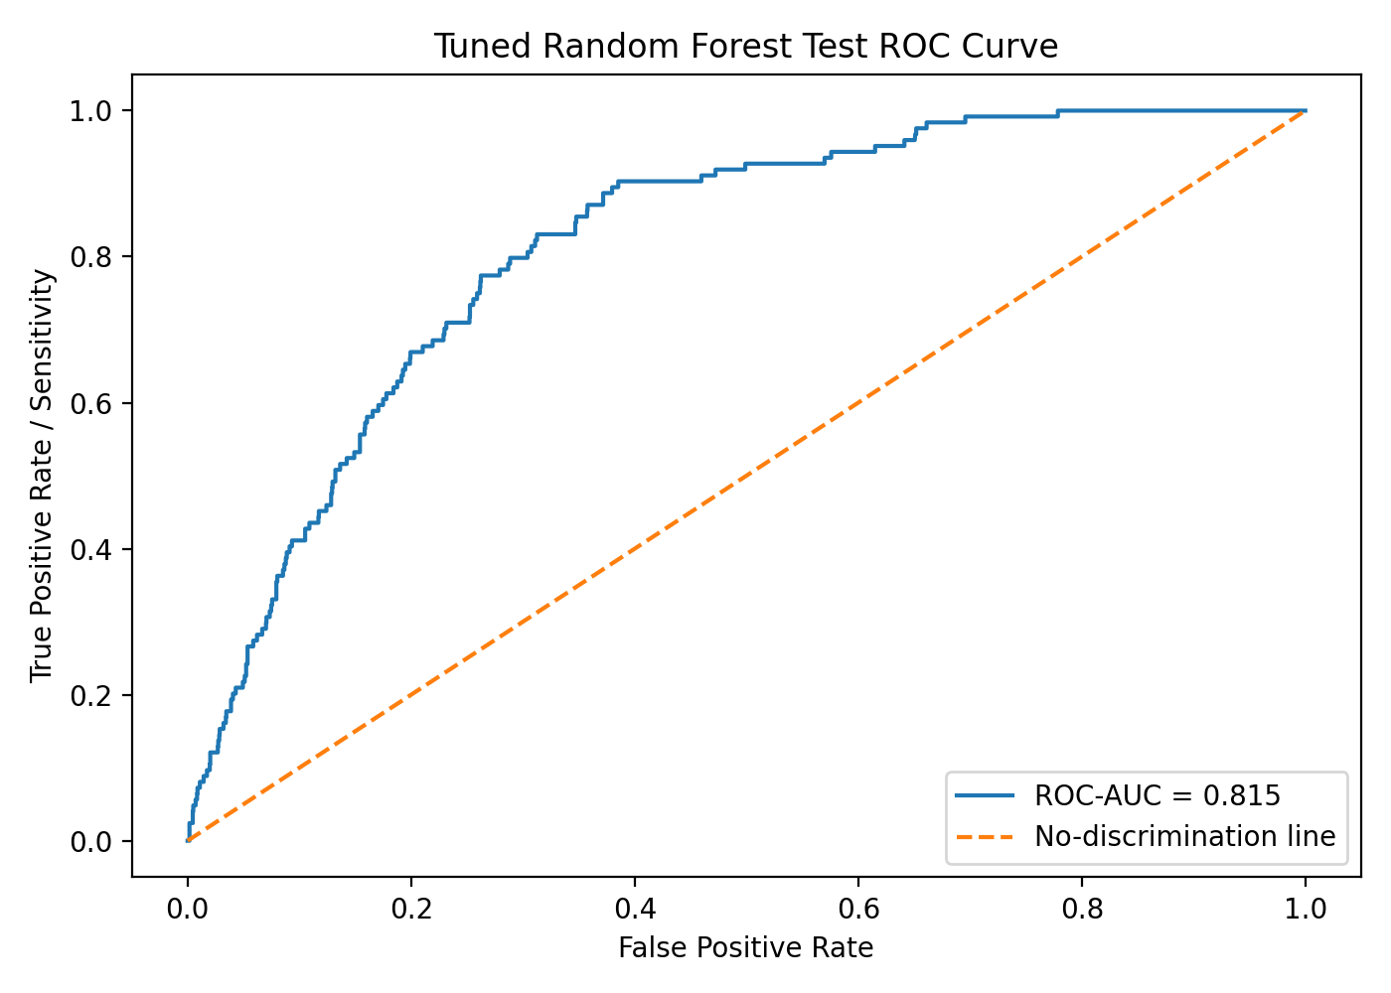
Figure: Tuned random forest test ROC curve.
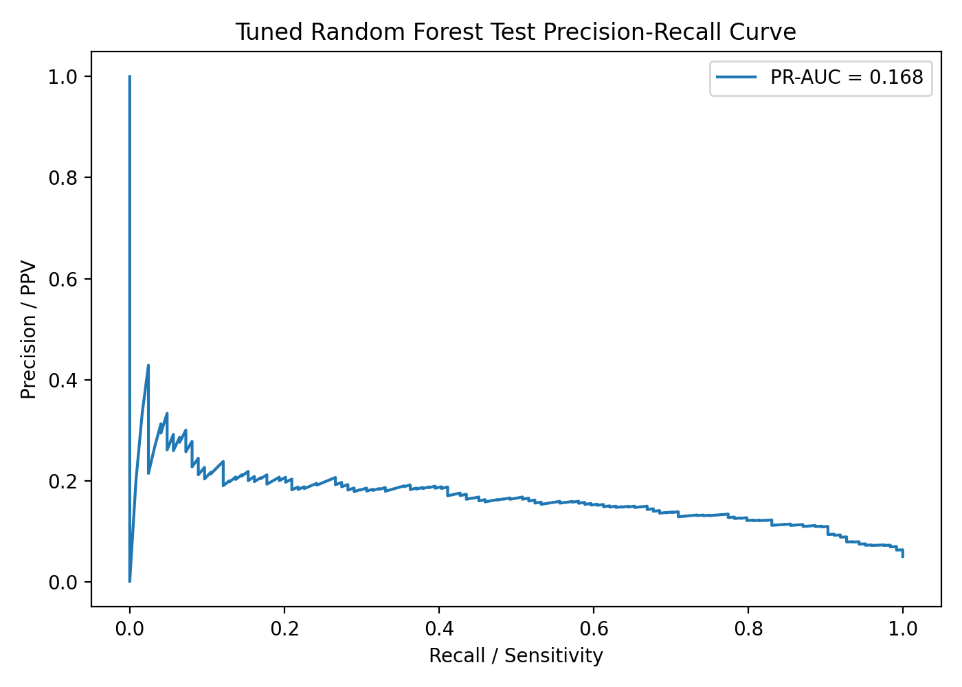
Figure: Tuned random forest test precision-recall curve.

C. Threshold comparison table
threshold | accuracy | sensitivity_recall | specificity | precision_ppv | f1_score | balanced_accuracy | tn | fp | fn | tp
0.0500 | 0.1999 | 1.0000 | 0.1580 | 0.0586 | 0.1107 | 0.5790 | 374 | 1993 | 0 | 124
0.1000 | 0.3384 | 0.9919 | 0.3042 | 0.0695 | 0.1299 | 0.6481 | 720 | 1647 | 1 | 123
0.2000 | 0.5560 | 0.9113 | 0.5374 | 0.0935 | 0.1697 | 0.7243 | 1272 | 1095 | 11 | 113
0.3000 | 0.6568 | 0.8548 | 0.6464 | 0.1124 | 0.1987 | 0.7506 | 1530 | 837 | 18 | 106
0.3500 | 0.6772 | 0.8306 | 0.6692 | 0.1163 | 0.2040 | 0.7499 | 1584 | 783 | 21 | 103
0.4000 | 0.7009 | 0.8065 | 0.6954 | 0.1218 | 0.2116 | 0.7509 | 1646 | 721 | 24 | 100
0.5000 | 0.7627 | 0.7097 | 0.7655 | 0.1369 | 0.2295 | 0.7376 | 1812 | 555 | 36 | 88
0.6000 | 0.8378 | 0.5242 | 0.8542 | 0.1585 | 0.2434 | 0.6892 | 2022 | 345 | 59 | 65
0.7000 | 0.9221 | 0.1774 | 0.9611 | 0.1930 | 0.1849 | 0.5693 | 2275 | 92 | 102 | 22
0.8000 | 0.9490 | 0.0081 | 0.9983 | 0.2000 | 0.0155 | 0.5032 | 2363 | 4 | 123 | 1

D. Comparison with baseline random forest test results
model | threshold | accuracy | sensitivity_recall | specificity | precision_ppv | f1_score | balanced_accuracy | roc_auc | pr_auc_average_precision | tn | fp | fn | tp
Baseline RF default threshold | 0.5000 | 0.9490 | 0.0000 | 0.9987 | 0.0000 | 0.0000 | 0.4994 | 0.8006 | 0.1491 | 2364 | 3 | 124 | 0
Baseline RF exploratory test threshold | 0.0420 | 0.7110 | 0.8145 | 0.7055 | 0.1266 | 0.2191 | 0.7600 | 0.8006 | 0.1491 | 1670 | 697 | 23 | 101
Tuned RF default threshold | 0.5000 | 0.7627 | 0.7097 | 0.7655 | 0.1369 | 0.2295 | 0.7376 | 0.8148 | 0.1681 | 1812 | 555 | 36 | 88
Tuned RF training-selected threshold | 0.3500 | 0.6772 | 0.8306 | 0.6692 | 0.1163 | 0.2040 | 0.7499 | 0.8148 | 0.1681 | 1584 | 783 | 21 | 103

E. Comparison with training cross-validation performance
data_source | threshold | accuracy | sensitivity_recall | specificity | precision_ppv | f1_score | balanced_accuracy | roc_auc | pr_auc_average_precision | tn | fp | fn | tp
Training CV selected model | 0.4700 | 0.7462 | 0.8065 | 0.7430 | 0.1412 | 0.2404 | 0.7747 | 0.8239 |  | 1758 | 608 | 24 | 100
Test at user-specified selected threshold 0.35 | 0.3500 | 0.6772 | 0.8306 | 0.6692 | 0.1163 | 0.2040 | 0.7499 | 0.8148 | 0.1681 | 1584 | 783 | 21 | 103

F. Top transformed-feature importance
feature | importance
age | 0.5180
avg_glucose_level | 0.1186
bmi | 0.0748
ever_married_No | 0.0581
hypertension | 0.0406
ever_married_Yes | 0.0329
heart_disease | 0.0216
work_type_children | 0.0189
smoking_status_Unknown | 0.0147
work_type_Self-employed | 0.0146
smoking_status_never smoked | 0.0128
work_type_Private | 0.0119
Gender_Female | 0.0106
Residence_type_Urban | 0.0105
smoking_status_formerly smoked | 0.0093

G. Grouped original-variable importance
original_variable | importance
age | 0.5180
avg_glucose_level | 0.1186
ever_married | 0.0910
bmi | 0.0748
work_type | 0.0545
smoking_status | 0.0433
hypertension | 0.0406
heart_disease | 0.0216
Residence_type | 0.0192
Gender | 0.0183

Interpretation
At the default threshold of 0.50, the tuned random forest identified 88 of 124 stroke cases, with sensitivity of 0.7097 and specificity of 0.7655. This was a major improvement over the baseline random forest at threshold 0.50, which identified no stroke cases.
At the training-selected threshold of 0.35, sensitivity increased to 0.8306, identifying 103 of 124 stroke cases. This reduced false negatives to 21, but increased false positives to 783 and lowered specificity to 0.6692.
Compared with the baseline random forest’s exploratory test threshold, the tuned model at threshold 0.35 achieved similar sensitivity and a slightly higher true-positive count, but it produced more false positives than the earlier baseline exploratory threshold. Therefore, sensitivity improved compared with the baseline default threshold, but false positives remain a serious concern.
Compared with training cross-validation, the tuned model generalized reasonably in ROC-AUC and PR-AUC. However, the user-specified test threshold of 0.35 is lower than the previously training-selected threshold of 0.47, so it prioritizes sensitivity more aggressively and accepts additional false positives.
The most important model-associated predictors were age, average glucose level, ever-married indicators, BMI, work type, smoking status, hypertension, and heart disease. These feature importance values are model-associated only and do not establish causation, statistical significance, or clinical readiness.
The tuned random forest may be more useful as a screening-support model than the baseline random forest because it detects many more stroke cases. However, low precision and many false positives mean it should not be used as a standalone diagnostic model.

Files saved in this stage
- tuned_random_forest_test_metrics.csv
- tuned_random_forest_test_threshold_comparison.csv
- tuned_random_forest_test_predictions.csv
- tuned_random_forest_test_roc_curve.png
- tuned_random_forest_test_precision_recall_curve.png
- tuned_random_forest_test_feature_importance.csv
- tuned_random_forest_test_grouped_feature_importance.csv
- tuned_random_forest_test_vs_baseline_comparison.csv
- tuned_random_forest_train_cv_vs_test_comparison.csv
- tuned_random_forest_test_evaluation_code.py

